Iperf3 network Tester
  - iperf3 Network Tester - An independent software-engineering research study
  - Room + KMP SQLite Persistence
Source: ROOMDBPLAN.md, branch roomdbkmp
Author: Jerry Abramson (with Claude Code)
Date: 2026-07-25
Status: Planning / Implementation
Assistants: qwen/qwen3.6-35b-a3b + Claude Code
Local AI Detals: See Appendix A
Claude Code Details: See Appendix B
Local System Details: See Appendix C

Goal
Persist a completed ResultData run to a local SQLite database on all three targets (Android, iOS, Desktop), replacing the simulated delay(3.seconds) in Iperf3RunViewModel.saveResult() with a real Room insert, and read it back reliably — guid, timestamps, and numeric results all survive a round trip.
CSV export and a results-history/browse screen are explicitly out of scope for phase 1 (see Phasing). Getting one row saved and re-readable end-to-end on all three targets is the hard part; export/browsing are then straightforward additions.

Preliminary Exercise
Initial planning utilized a code lab exercise to convert a roomdb Android App to KMP.
Migrate Room To KMP codelab: "Fruitties" shopping app
- https://developer.android.com/codelabs/kmp-migrate-room
This exercise starts as an Android app (Room + CoreData duplicated per-platform) and is migrated so the Room database is shared between Android and iOS via Kotlin Multiplatform.

What's Already Scaffolded
This isn't a green field — the schema and save-button UX were already designed and then backed out as comments. Don't re-derive them.
model/ResultData.kt — entity fields fully designed; @Entity/@PrimaryKey/@TypeConverters(UuidTypeConverter::class) present as comments, referencing a converter that doesn't exist yet.
viewmodel/Iperf3RunViewModel.kt — commented imports name the intended package (.../database/) and classes (ResultDatabase, ResultDataRepository).
saveResult() already has the full save UX: guards, isSaving/isSaved state, a stub delay standing in for the real insert, and a TODO("Export as CSV") for the second click.
SaveButton.kt already models the Save → Export button-label transition.
UiExecutionData.isDatabaseCreated: Boolean already exists, always false today — clearly meant to gate the UI on DB readiness.

Key Design Decisions

1. Entity ≠ domain model
Don't annotate ResultData directly. Its guid/startDateTime fields are expect/actual interfaces that only know how to generate a new value (AndroidUUID() calls UUID.randomUUID() in its constructor) — there's no way to reconstruct one from a stored string yet. Its UnitConvertedData fields (max/min/avg/median/stdDev) also duplicate the raw Long bps fields already on the class.
Recommendation: a separate ResultDataEntity with only primitive/String/Long columns, plus mapper functions (toEntity() / toDomain()). Drop the UnitConvertedData columns and recompute them from raw bps at display time. This needs zero new TypeConverters.

2. SQLite driver per platform
The codelab covers Android + iOS only; this project adds a third driver for desktop:
Platform | Driver | Artifact
Android | AndroidSQLiteDriver() | androidx.sqlite:sqlite-framework-android
iOS | NativeSQLiteDriver() | androidx.sqlite:sqlite-framework (cinterop)
Desktop (JVM) | BundledSQLiteDriver() | androidx.sqlite:sqlite-bundled

commonMain gets expect fun createSQLiteDriver(): SQLiteDriver, mirroring the existing getPlatform()/getAppUUID() pattern already in Platform.kt.

3. Android Context — no DI container exists
App() is called with zero arguments on all three platforms; there's no Hilt or other DI. Room's Android driver needs a Context. Recommendation: one explicit line in MainActivity.onCreate() that stashes applicationContext in a small androidMain singleton — simpler than pulling in androidx.startup, which would need a manifest entry in :shared that doesn't currently exist.

4. Migrations — skip for now
This is a coursework/research project, not a shipped app with user data to protect across schema changes. Use fallbackToDestructiveMigration(dropAllTables = true) and say so in a comment; revisit only if a real reason to preserve data across a schema bump appears.

5. Schema export
Follow the codelab convention: room { schemaDirectory("$projectDir/schemas") }, commit the generated JSON under shared/schemas/ — cheap, and gives a diffable record of schema changes even without migrations.

Gradle / Dependency Changes
None of this exists yet — no ksp, room, or sqlite entries currently in gradle/libs.versions.toml. Existing plugin repos already cover what's needed; no repository changes required.
gradle/libs.versions.toml — add KSP plugin, androidx-room (2.8.4+, pending verification), androidx-sqlite (2.7.0+), and the three sqlite driver artifacts.
shared/build.gradle.kts — apply KSP + androidx.room plugins, add kotlin { jvmToolchain(17) }, room { schemaDirectory(...) }, per-source-set dependencies, and kspAndroid / kspIosArm64 / kspIosSimulatorArm64 / kspJvm processor registrations.
iOS framework blocks — add linkerOpts.add("-lsqlite3") (already anticipated in AGENTS.md's iOS ARM-only note).
androidApp/build.gradle.kts — add Room runtime + KSP compiler dependency (needed transitively for app-level codegen).

New Files
Package: com.jabramson.iperf3_network_tester_kmp.database (matching the commented-out import path already in the ViewModel).
commonMain/.../database/ResultDataEntity.kt, ResultDataDao.kt, ResultDatabase.kt, Database.kt (expect driver + builder helper), ResultDataMappers.kt, ResultDataRepository.kt
androidMain/.../database/Database.android.kt + AndroidAppContextHolder.kt
iosMain/.../database/Database.ios.kt
jvmMain/.../database/Database.jvm.kt

ViewModel / UI Wiring
Give each platform entry point (MainActivity, main.kt, MainViewController) responsibility for constructing the platform ResultDatabase and passing a ResultDataRepository into Iperf3RunViewModel's constructor — more testable than a platform-singleton lookup inside the ViewModel.
Replace the delay(3.seconds) stub in saveResult() with repository.insert(current.toEntity()), inside the existing isSaving/isSaved bracketing — the UX state machine doesn't change.
Set isDatabaseCreated = true once the repository is constructed successfully; surface construction failure rather than leaving the flag silently false.
Leave TODO("Export as CSV") as-is — phase 2.

Testing
androidHostTest — unlike the JNI-based StringFormatterTest (excluded because Robolectric can't load a real .so), Room's AndroidSQLiteDriver is pure JVM/framework code Robolectric does support. Worth confirming early — likely the fastest test loop for this feature.
jvmTest — exercise BundledSQLiteDriver, in-memory or temp file.
iosSimulatorArm64Test — exercise NativeSQLiteDriver; also where the -lsqlite3 linker flag first gets proven (fails to link before it fails to run, if missing).
No commonTest DB test — the driver is platform-specific by construction.
Minimum bar for “done”: insert a ResultDataEntity built from a real ResultData, read it back by guid, assert field equality — run on all three test targets.

Phasing
Phase | Scope
1 — this plan | Schema, drivers, repository, wire saveResult() to a real insert, round-trip test on all three targets, manually verify via run on each platform.
2 — follow-on | CSV export (TODO already in code) and/or a results-history list screen backed by getAll(). No new architectural decisions — just new UI on top of phase 1's plumbing.

Risks / Open Questions — Spike Before Committing
JVM desktop support: the codelab only proved Room on Android + iOS. Spike a throwaway single-entity database on :shared:jvmTest / :desktopApp:run before touching the real schema.
AGP plugin mismatch: this project uses the newer com.android.kotlin.multiplatform.library plugin, not the classic com.android.library + kotlin("multiplatform") combo most Room-KMP docs/samples assume — confirm kspAndroid codegen actually works under it.
minSdk 26 vs. codelab's 27: unclear if that's a real sqlite-framework-android requirement or just the codelab's own default — check the merged manifest before bumping android-minSdk.
`jvmToolchain(17)` vs. existing per-target `jvmTarget = JvmTarget.JVM_11`: a toolchain/target-bytecode mismatch is a common source of confusing build errors — verify the existing Android/Compose build doesn't regress.
KSP ↔ Kotlin 2.4.0 version pin: KSP releases are pinned to exact Kotlin versions — confirm the matching KSP release string before filling in the version catalog.

Full detail, code sketches, and rationale: ROOMDBPLAN.md in the repository root.

Appendix A – Local AI Specification

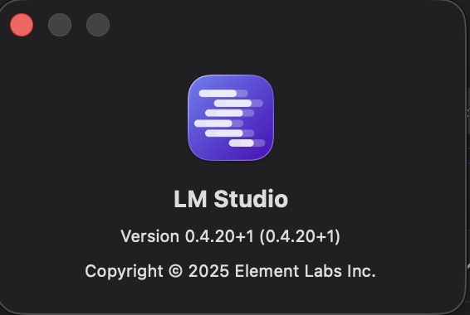 | 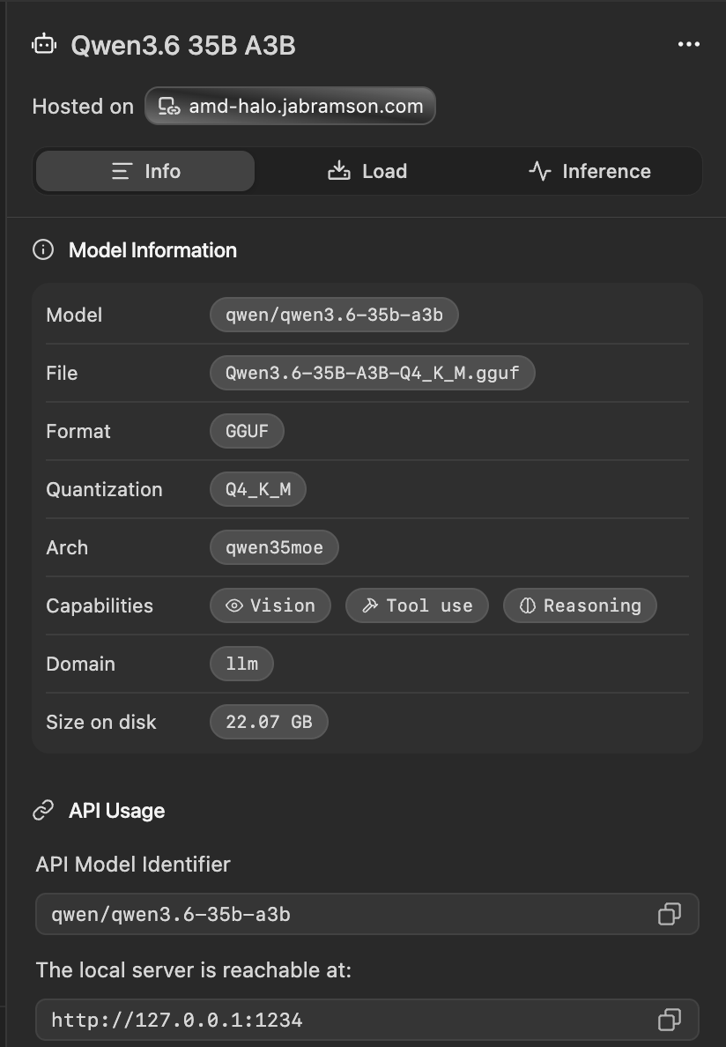

Appendix B – Claude Code Specification

Version: 2.1.220 Session name: Plan RoomDB and SQLite integration for project
Session ID: cef9fb0e-88fd-40e3-90c0-24457ee46c5d
cwd: REPO_ROOT
Login method: Claude Pro account
Organization:'s Organization Email:
Model: Default (Sonnet 5 · Efficient for routine tasks)
MCP servers: 2 disabled · /mcp
Setting sources: User settings, Project local settings

Appendix C – Local Systems
Local System | AI Server System
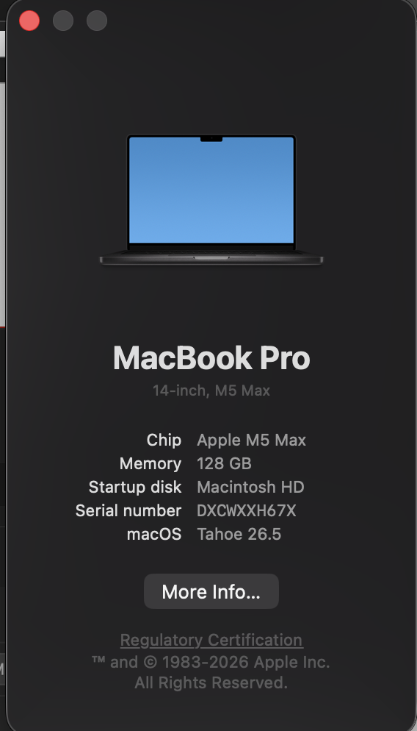 | 